Testing & Debugging JavaScript

By: Rob Levin
Version: 0.0.1
Dated: Mon, October 19, 2009
License: This document is licensed under the Attribution-NonCommercial-ShareAlike 3.0 Unsupported
Template Author: mayankjohri
License, available at http://creativecommons.org/licenses/by-nc-sa/3.0

Disclaimer
The information in this document is based on publicly available documentations and author's personal & professional experience. In no event shall author be liable for any direct, indirect, consequential, punitive, special or incidental damages (including, without limitation, damages for loss of profits, business interruption or loss of information) arising out of the use or inability to use this document, even if Author has been advised of the possibility of such damages. Author makes no representations or warranties with respect to the accuracy or completeness of the contents of this document and reserves the right to make changes to this document at any time without notice. Author does not make any commitment to update the information contained in this document.

Title | TDD JavaScript
Author | Rob Levin
Email | roblevintennis@gmail.com (author) johri.maya@gmail.com (template author)
Version | 0.0.1
Document Date | 10/19/09Notes
Table of Contents
Introduction 6
1.1. Why this book? 7
1.2. Rationale 7
1.3. Goals of this book 7
1.4. Who should read? 7
1.5. What this book is not? 8
1.6. Examples 8
1.7. Disclaimer 8
Part I – Debugging Tools 9
Firebug 9
2.1 Introduction 9
2.2 Installation 9
2.3 Usage 11
Selenium IDE 13
3.1 Introduction 13
3.2 Installation 13
3.3 Usage 13
Example of a Debugging Session 15
Part II – Testing Tools 15
Testing Methodologies 15
xUnit Frameworks 15
BDD Frameworks 15
YUI Test 16
4.1 Introduction 16
4.2 Installation 16
4.3 Usage 16
4.4 Setup, Teardown 20
4.5 Additional Features 21
4.6 YUI 3 21
QUnit 21
6.1 Introduction 22
6.2 Installation 22
6.3 Usage 22
6.4 FireUnit 24
jspec 26
7.1 Introduction 26
7.2 Installation 26
7.3 Usage 27
7.2 Additional Features 30
Callbacks 30
Options 30
Server Formatting 31
Other Tidbits 31
Summary 32
Unit Tests vs. Regression Tests 32
Part III – Test Driving JavaScript 33
Before we get started 33
5 Minute Drill 33
What just happened? 37
Objects 38
Object Creation 38
Accessing Object Properties 40
Object Assigned by Reference 40
Prototypes 41
Prototype Shadowing 42
Reinventing Thyself 42
Prototype Issue 43
Inheritance 45
Pseudoclassical 45
Prototype Shared State Issue 47
Constructor Stealing & Combination Inheritance 47
Prototypal Inheritance 48
Inheriting Prototypes Not Constructors 49
Functional Inheritance 50
Summary of Inheritance Patterns 52
JavaScript Gotchas 53
Namespace 53
parseInt 53
Equality and == vs === 54
Reserved Words in Object Literals 55
Scope 56
Privileged Singleton 57
Rolling Your Own Testing Framework 58
Best Practices 58
References 58
Notes to self 59
Oreilly Template 59

Introduction
Contents:
Introduction 6
1.1. Why this book? 7
1.2. Rationale 7
1.3. Goals of this book 7
1.4. Who should read? 7
1.5. What this book is not? 8
1.6. Examples 8
1.7. Disclaimer 8

Why this book?
While there are a plethora of good JavaScript books, blogs, etc., information on testing JavaScript is scattered across the net and a bit cumbersome to wade through. The author's hope is to remedy this with a nice “ramp up” document for developers that need to get up and running quickly.

Rationale
Most programming books put off getting in to things like debugging and testing until very late in the book (if at all). This is a bit of a shame because debugging and testing are not only indispensable skills, they're actually quite helpful in aiding the learning of a new language.

An example of using testing to learn and confirm features of a new language can be found in the Part II: The xUnit Example in Kent Beck's TDD By Example book. Mr. Beck actually uses unit testing to both “play” with Python and build a unit testing framework from out of thin air! [BKTDD2002]

TDD JavaScript will attempt to allow the user to “kill two birds with one stone” - get up to speed on both JavaScript and testing JavaScript programs.

Goals of this book
This book is not meant to be an exhaustive reference or even complete tutorial on JavaScript – there are already a number of good choices for that:
- JavaScript: The Good Parts by Douglas Crockford
- JavaScript: The Definitive Guide by David Flanagan
- Professional JavaScript for Web Developers by Nicholas C. Zakas
- Books and blogs by John Resig
There are of course others as well – these are some the author can vouch for. Please note that these may be considered advanced so a newbie will likely need another resource before tackling any of these. Both w3schools and Mozilla, have some very nice free online alternatives for those just trying to get started.

https://developer.mozilla.org/en/Core_JavaScript_1.5_Guide
http://www.w3schools.com/js/default.asp

This book's primary goals are:
- Get you up and running using JavaScript AND testing quickly.
- Act as supplemental material to more authoritative tomes (see books above).

Who should read?
This book is aimed at the following cross-section of readers:
- Those coming to JavaScript from another language (eg Java, PHP, C#, etc.)
- JavaScript programmers that would like to test, but only if they can get set up and going quickly.
- Those that have avoided JavaScript like the plague in favor of server side programming, but now find themselves in a project that demands client-side programming skills.
- A fast reader that wants to do an hour's research and get a sense of some of the tools presented before wading through a bunch of README's and environment setup. If this is you, just read the first part of this book to get a sense of some nice JavaScript tools available.
- Although this book isn't targeted at newbies, the exploration of testing frameworks, and setting up a solid JavaScript development environment should prove as valuable supplemental material. If things get too complicated, just move on to another section and come back to these sections later in career.

If you are already a JavaScript guru, have already set up a complete TDD JavaScript environment, etc., this book may not be for you. You may want to cherry pick the chapters that interest you specifically. Perhaps there's a tool or two covered that you just haven't got around to using yet? Moreover, you may have the job of getting a new hire, junior developer, etc., to use some discipline in their JavaScript development but don't have time to pair program them. You may consider using this as a resource to “throw at them”.

What this book is not?
A lot! We are not going to get into every testing framework or debugger and we will be doing most of our work in Firefox. That being said, the reader is definitely encouraged to also test their scripts in IE, Chrome, Safari, Opera, etc. However, there's just not enough room for this book to cover all of these.

As brevity is one of the chief goals of this document, it will be up to the reader to find other background material to learn the rationale for things like TDD (test driven development), BDD, xUnit. One suggestion, is that if this book makes a foreword reference to something you are not familiar with, take 10 minutes to read the Wikipedia, etc. Moreover, we won't be getting into every feature available from each framework. Unfortunately, that means Ajax, mocks and stubs, and certain other features have been left out. The goal is to give you a point of departure from which you can move into these more interesting areas on your own.

Also, this book does not try to get deep into the JavaScript language itself. It is meant to be used as supplemental material to a more “proper” JavaScript book. The author does plan to use parts of the Zakas and Crockford books previously mentioned to inspire some of the examples later in the book (specifically, we will use some tests to iron out confusion of Object Creation and Inheritance). If the reader is so inclined, they will probably get a lot out of using this as a study aid on top of those more exhaustive resources. But not, neither is for the faint or heart!

Lastly, this document is not meant to act as a comparison chart or matrix on the tools examined!

Examples
The code examples were ran on either Mac OS X (10.5.8) or Ubuntu 8+ system (or both) running Firefox 3.5.3. You system's results may be different.

The author maintains a repository on github with the book itself, as well as any supplemental code, etc., at:
http://github.com/roblevintennis/Testing-and-Debugging-JavaScript
As it is always challenging to take source code from a word processed document, it is strongly suggested that you grab the code from there (as opposed to cut and pasting from this document). Moreover, it is likely that any updates in the source will be in the github code before this document!

Disclaimer
This is a free book, and the author is doing this on the side (on top of full time development and family concerns). As it is more important to get the information “out there” and provide that it is accurate, the formatting may leave much to be desired. If this really bothers the reader, and they
have the knowledge to do so, they may contribute to this project by reformatting the book (if they are so inclined). If so, please create a clone and add it. Moreover, the author does not claim to be a superstar of JavaScript wizardry – if you are only interested in getting information from the “heads of state”, please see the list presented earlier (or search for JavaScript + any of the following: Crockford, Zakas, Resig, Flannigan, Edwards, PPK, etc.)

Part I – Debugging Tools
This section of the book is meant to provide short chapters on some of the various tools available for debugging and testing JavaScript.

Firebug
Contents:
Firebug 9
2.1 Introduction 9
2.2 Installation 9
2.3 Usage 11

2.1 Introduction
Firebug is a Firefox Add-on that gives you a grab bag of web development tools to aid in debugging your JavaScript code. You can use it: as a JavaScript interpreter; to inspect DOM elements on a web page; edit HTML, CSS, and JavaScript in-place and view the results live in your browser; debug code using typical breakpoint/step functionality found in IDE debuggers; view network stats to determine page responsiveness. The current url for Firebug is: http://getfirebug.com/

There's also a great presentation by the original author himself, Joe Hewitt: http://yuiblog.com/blog/2007/01/26/video-hewitt-firebug/

2.2 Installation

The following screen-shots show what the author did to install the Firebug Add-on for Firefox:

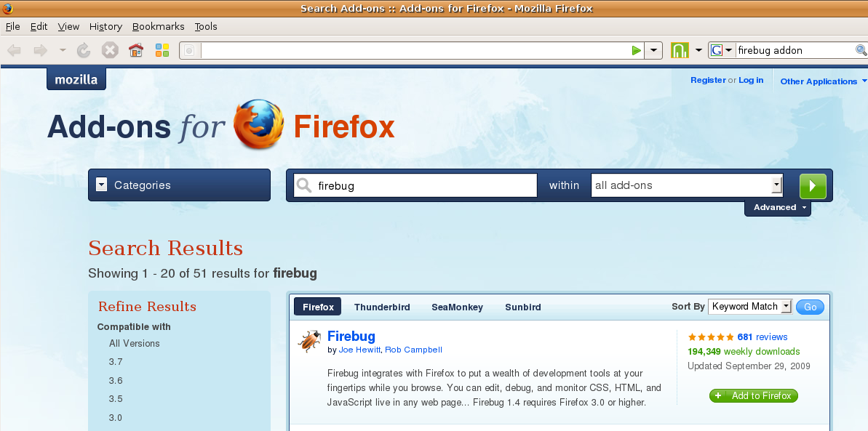
Figure 1-1. Finding Firebug is easy from the Firefox Add-ons search page.

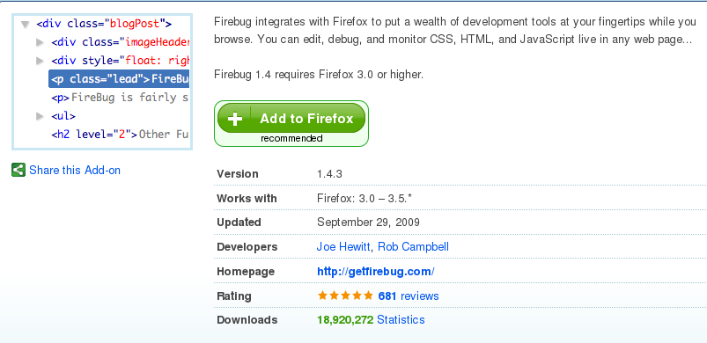
Figure 3-2. Click the Add to Firefox (green button)

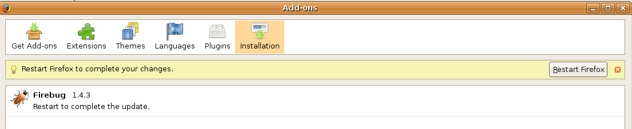
Figure 3-3. Restart Firefox
Upon restarting Firefox, you will then have the Firebug Add-on installed. To actually use it, you have to open it up by either three methods: 1) Tools->Firebug->Open Firebug 2) Hitting the F12 function key 3) Clicking the little bug icon on your status bar (at the bottom of your browser). All of these should present you with something similar to the following where you can verify the console works by typing in a simple log message and clicking the 'Run' at the bottom of the console input pane (it's highlighted in the screen-shot below):
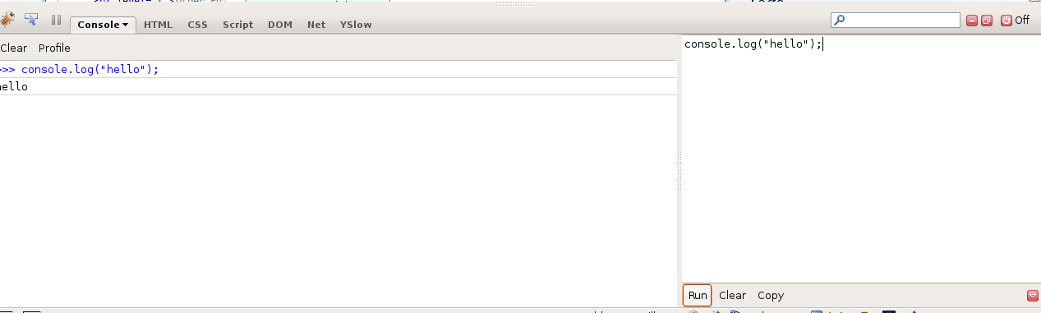
Figure 3-4. Verifying Firebug console with a simple console.log(“hello”) message and clicking the 'Run' button
In the above, you've used the Firebug console interpreter to enter JavaScript directly into the input pane (shown right) and have it output the result of executing that JavaScript (show left). The console.log(“hello”) is simply a call to the log method on the console object with the string message 'hello'. We'll be using this logging functionality throughout the rest of this book so make sure you can duplicate the result before moving on.

2.3 Usage
As this book is aiming at brevity we'll show you just a couple more of the features of Firebug. There's a ton of hidden features that are very useful and I suggest watching the Joe Hewitt video previously cited.
If you go to any web site with Firebug open and click the 'Net' tab, you should see page load information similar to that in Figure 3-5. Note that if you don't initially see anything, you may have to Reload the web page. One thing not shown in the figure is that if you scroll to the button of the Net section, you can determine the total page load time which will show up on the bottom right side. This is very useful when trying to improve the page responsiveness of your site. Perhaps you have many different includes that are each causing a separate HTTP request and should consider creating one amalgamation file instead? Have you minified your JavaScript? Is my image too big?These are advanced topics but exemplify how you may use the Net tab to improve response time.
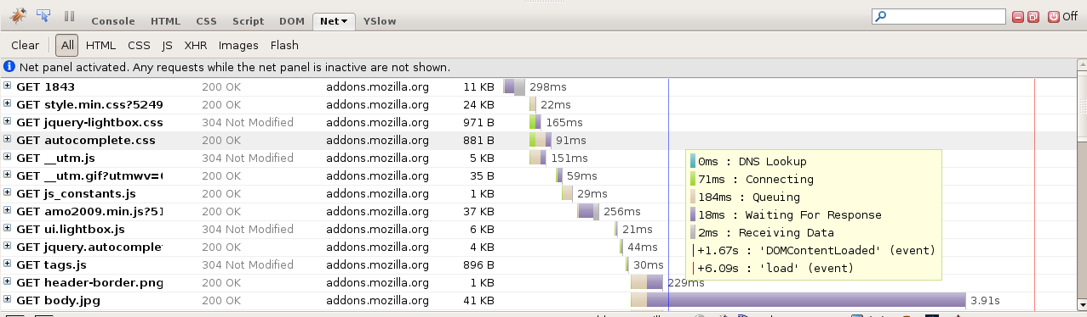
Figure 3-5. Clicking on the Net tab and then reloading a web page. Notice the yellow stat box? That shows up from simply hovering over one of the timeline bars. This allows you to see how long certain parts of the page are taking to load.
Below is a screen-shot showing how to use the inspector to find the exact DOM for a particular item on a web page. Note that the inspector icon (just to the right of the bug) may look differently on your system.

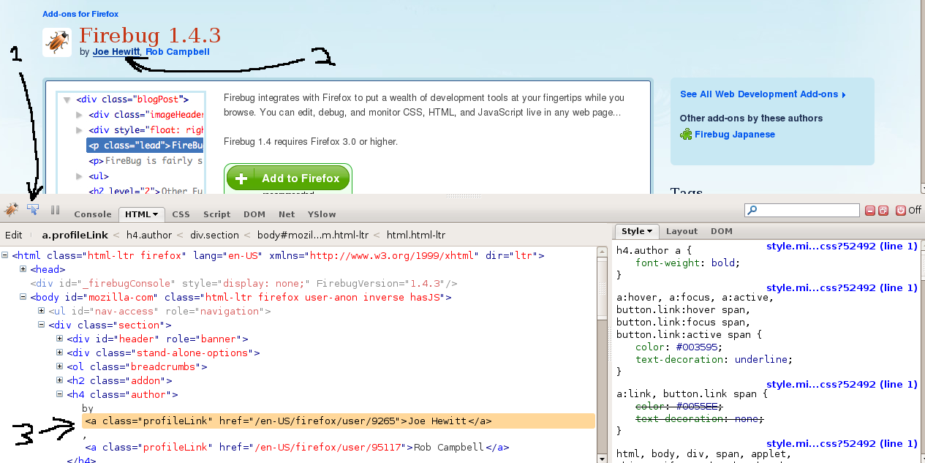
Figure 3-6. Firebug Inspector. 1) We click the inspector icon 2) We click on a page item (“Joe Hewitt”) 3) Firebug shows the exact HTML element within the markup!
Note that you can also right-click (or context-click on a Mac) the highlighted HTML element and a context menu will appear in which you can select useful things like Copy XPath. This gives you the valid XPath string you can paste later, which may look something like:
//html/body/div/h4/a

This will be useful later when we use another tool Selenium IDE. As mentioned, this indispensable tool has much more to offer like breakpoints and step execution. Some of this will be discussed in later chapters as appropriate.

Note that the following chapters (to save space) will not show as much installation detail, and will assume that you can figure out how to download and install the libraries yourself.

Selenium IDE
Contents:
Selenium 12
3.1 Introduction 12
3.2 Installation 12
3.3 Usage 12

3.1 Introduction
Selenium is a comprehensive suite of software for testing applications from within the context of the browser. It is really a blasphemy to call it a debugging tool as it's so much more! However, it seems to fit nicely here (apologies to those offended!), and we're only going to get into simple usage of the IDE portion of this suite of tools.

Selenium itself, consists of Selenium Core, Selenium IDE, Selenium RC, and Selenium Grid. This book will focus on Selenium IDE which is a Firefox Add-on. The IDE allows you to “record in” your browser interface interactions (eg Open the http://localhost:3000/events page, click the Create New Record button, etc.). You can then “playback” these interactions and you will see the browser responding to these prerecorded interactions (much the way the old player pianos would play a song and the piano keys would move as if an invisible person was playing it).

You can also manually type in such commands (as opposed to recording them). The best way to understand the IDE is to begin playing with it.

3.2 Installation
You can essentially search the Firefox Add-on site for Selenium IDE and install exactly as you did with Firebug. If you've installed it successfully, it should show up in the Tools menu of Firefox.

3.3 Usage
When you first open up Selenium IDE, the record key (the red key on the upper right hand side) will be engaged. This means that you are already in record mode. You can of course toggle this off if you wish, but for the purposes of our discussion, we'll leave it engaged. Simply interact with you web browser (eg open one of your pages, try to carry out a user story, etc.) and then click the record button to turn recording off.
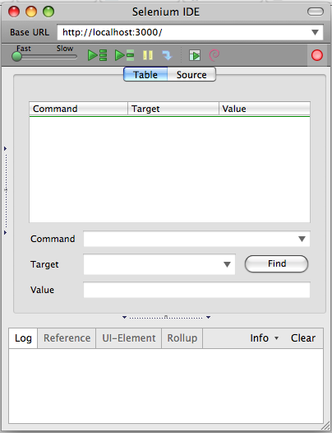
Figure 4-1. Selenium IDE opens up in record mode so you can start recording your browser interactions
TODO:
- Put in a section which shows creating a test suite for a simple application and put source in /code in repository.
- Mention something about the problem of having to open the browser, manually running test, alternatives including Selenium RC, possibly Cucumber and Webrat, etc.

Example of a Debugging Session
– Put in an example of using Firebug and Selenium to debug a script –

Part II – Testing Tools

Testing Methodologies

This section (and the rest of this book) will assume that the reader has been exposed to some type of unit testing framework, be it an xUnit variant like Junit, or a BDD variant like RSpec.

xUnit Frameworks
The first testing framework we'll discuss is the YUI Test framework – this is an xUnit testing framework. With xUnit testing frameworks there are test methods, test cases, and test suites. There's also a test runner for executing the tests.

- Test methods allow you to test one isolated piece of functionality in your software.
- Assertions are usually one executable line of code that asserts that some condition has some characteristic (e.g. something is true, something is of a particular object type, etc.)
Test methods generally have one or more assertions.
- Test cases are one or more test methods cohesively grouped to test one object or module.
- Test suites are just a way of grouping test cases so that they will all run together (just as a musical suite would be a group of songs that are to be performed together).

Usually, you will have one object under test that will map to one particular test suite, with methods of that object being tested individually by test cases. [ZNTDD2008]

In order to run, either an individual test case or a suite of such test cases, a test runner acts essentially as a driver bootstrapping the suite of tests.

BDD Frameworks
BDD tends to emphasize the inclusion of stakeholders by using an outside-in process which focuses on the goals of the stakeholder, and then works its way in to the system that supports these goals. It starts by describing what a unit of software should do and then makes some assertions about that functionality with the idiom of starting with 'it should' (do such and such).

According to Dan North, the pioneer of this methodology, 'if the methods do not comprehensively describe the behaviour of your system, then they are lulling you into a false sense of security.' Essentially, his solution is to do away with the testMethod convention, and instead describe the desired behavior of the thing being tested. [NDBDDINTRO]

BDD may have some advantages over traditional xUnit in that it's more closely tied to the specific features required by the stakeholders, thus insuring that you only write software you need, but there's nothing preventing achieving similar results from xUnit testing. It really is a matter of preference and taste.

For a more complete discussion of both xUnit and BDD please see:

http://en.wikipedia.org/wiki/XUnit
http://en.wikipedia.org/wiki/Behavior_driven_development

The jspec framework is a BDD testing framework – a whole chapter is devoted to this framework later in the book. There, we will get deeper into what's involved with using BDD.

YUI Test
Contents:
YUI Test 16
4.1 Introduction 16
4.2 Installation 16
4.3 Usage 16
4.4 Setup, Teardown 20
4.5 Additional Features 21
4.6 YUI 3 21

4.1 Introduction
According to Yahoo's yuitest page located at the time of this writing at:
http://developer.yahoo.com/yui/yuitest
“YUI Test is a testing framework for browser-based JavaScript solutions. Using YUI Test, you can easily add unit testing to your JavaScript solutions. While not a direct port from any specific xUnit framework, YUI Test does derive some characteristics from nUnit and Junit.”

It allows for the creation of test cases, test suites, asynchronous testing and more.

4.2 Installation
For our purposes, we'll go ahead and download the includes straight from Yahoo's servers from within our script so we don't have to actually install anything! However, you may wish to download and host the yuitest includes on your server (which I will leave to the reader to do for themselves if so).

If you'd like to optimize your includes, you can use the YUI Dependency Configurator which will allow you to choose the specific YUI components you want to use on your web page. You can also choose to combine all JS files into a single files which will reduce the number of HTTP requests improving your browser page load time dramatically. However, we will not use this tool to configure our setup as it is out of the scope of this document.

Please note that the bulk of this chapter uses YUI Test from YUI 2. The latest version is YUI 3 and there is a move in this direction. Therefore, you can find a bare minimum working example in the github repository for this book. See the last section of this chapter for more details.

4.3 Usage
Getting yuitest to work is fairly straight forward. You basically need to require all of the boiler plate CSS, dependencies, and yuitest source code. Once you've done that, you will create one or more test cases, each of which will in turn contain individual test methods, and then add those test cases to a test suite. Lastly, you will instantiate a test runner object and call run on that object (essentially bootstrapping the running of the test suite). If you're impatient, you should be able to just “load and go” the source code in the repository under /code prefixed with yui_test

In general, it is advised that for each object you want to test you have ([ZakasTDD2008]):
- One test case for each method in the object. This test case will contain one or more test methods to test the various aspects of the object method. For example, if you are testing an addTwoNums method, you may one test method that tests if 1 + 2 == 3, another that tests that -1 + 3 == 2, yet another that insures that an exception is thrown if an invalid value is passed in (eg NotANumber), etc. So all of these test methods combined are meant to exercise the one method in the object.
- One test suite per object. If you have two methods in your object under test, you may have two test cases with one or more test methods, and then add those test cases to a test suite which will effectively test that one object.

The following code creates an HTML file that includes another JavaScript file (as we typically do). Upon loading this into a browser window you should see the YUI test results widget showing your success or failure (please use code from github as opposed to cut and pasting this code!):

yui_test.html

<html>
<head>

<!-- Add Logger -->
<link rel="stylesheet" type="text/css" href="http://yui.yahooapis.com/2.8.0r4/build/logger/assets/logger.css">
<link rel="stylesheet" type="text/css" href="http://yui.yahooapis.com/2.8.0r4/build/yuitest/assets/testlogger.css">

<!-- Dependencies -->
<script type="text/javascript" src="http://yui.yahooapis.com/2.8.0r4/build/yahoo-dom-event/yahoo-dom-event.js"></script>
<script type="text/javascript" src="http://yui.yahooapis.com/2.8.0r4/build/logger/logger-min.js"></script>

<!-- YUI Test Source -->
<script type="text/javascript" src="http://yui.yahooapis.com/2.8.0r4/build/yuitest/yuitest-min.js"></script>

<!-- Our JS file with the test cases, test suite, and test runner instances -->
<script src="yui_test.js"></script>

</head>
<body>
</body>
</html>

yui_test.js

// Simple test case 1
var nameAgeTest = new YAHOO.tool.TestCase({

name: "Test Name and Age",

setUp : function () {
this.data = { name : "Rob", age : 39 };
},

tearDown : function () {
delete this.data;
},

testName: function () {
YAHOO.util.Assert.areEqual("Rob", this.data.name, "Name should be 'Rob'");
},

testAge: function () {
YAHOO.util.Assert.areEqual(39, this.data.age, "Age should be 39");
}
});
// Simple test case 2
var fooNumTest = new YAHOO.tool.TestCase({

name: "Test Foo Num",

setUp : function () {
this.data = { foo : "FOO", num : 123 };
},

tearDown : function () {
delete this.data;
},

testFoo: function () {
YAHOO.util.Assert.areEqual("FOO", this.data.foo, "foo should be 'FOO'");
},

testBar: function () {
YAHOO.util.Assert.areEqual(123, this.data.num, "num should be 123");
}
});

// Create a test suite and add the two test cases from above
yuiSuite = new YAHOO.tool.TestSuite("YUI Test Suite");
yuiSuite.add(nameAgeTest);
yuiSuite.add(fooNumTest);

YAHOO.util.Event.onDOMReady(function (){

var logger = new YAHOO.tool.TestLogger();// Create logger
YAHOO.tool.TestRunner.add(yuiSuite); // Add Suite to test runner
YAHOO.tool.TestRunner.run(); // Call run on the runner to run tests
});

Upon grabbing the above source code from your github downloaded code, and putting it on your local hard drive, you should be able to go to your browser and enter something similar to the following URL (depending of course on the exact path to your file):

Figure 3-1. Entering a file URL in the browser to test a file on your computer
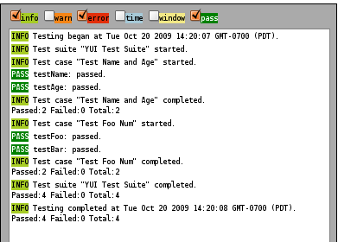
Figure 3-1. YUI test results.

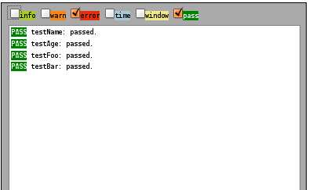
Figure 3-2.Same results with 'Info' unchecked.

If you get it to work you should do something creative to make it “break” so you can also see what it looks like to get a failure.

There are many other options available which you can learn more about yourself from the yuitest web site such as: AdvancedOptionsTestCase (which allows you to define tests that should fail, be ignored, or throw an error); Asynchronous Tests for testing Ajax; simulation of user interaction (note that this is a “moving target” between YUI 2 & 3 and you will need to get this from another package – see notes YUI 3 section); and many more features that are well beyond the scope of this book.

4.4 Setup, Teardown
As you may have noticed that in addition to our tests, there are two additional methods, setUp and tearDown. Intuitively, one defines and initializes a “data” object on this, while the other deletes it essentially cleaning up. The “data” object is what is called a fixture – basically a common resource that will be used for one or more tests. This allows us to avoid repetitiously creating the same object over and over again at the beginning of each method. The setUp and tearDown methods are hooks that will get called automatically before your tests run.

One important thing to note about the setUp and tearDown methods, is that they are called for each of your test methods and not just once for each test case. This insures that any results from one test case do not affect the integrity of following test methods. To prove this fact, I added a simple console.log to the setUp method for a test case that had exactly four test methods within it:
console.log("setUp called...");
/* Outputs:
setUp called...tearDown called...
setUp called...tearDown called...
setUp called...tearDown called...
setUp called...tearDown called...
*/
This exemplifies that fact that for each test method within a particular test case, both setUp and tearDown gets called as expected for an xUnit family testing framework.

4.5 Additional Features
Now that you have a working template to add to, I suggest that you create a copy of the file (so you don't clobber your working test), and then experiment with the available YUI Test assertions:
http://developer.yahoo.com/yui/yuitest/#assertions

Additionally, if you'd like to have a report of the test run sent to your site, you can enter a URL
var oReporter = new YAHOO.tool.TestReporter("http://you.com/path",YAHOO.tool.TestFormat.JSON);
oReporter.report(results);

In the above, you have specified a URL for the first parameter, and the JSON format for the second parameter.

There is other functionality such as asynchronous testing which basically allows you to simulate “waiting” for a specified amount of time before a callback gets invoked. This is again outside the scope of this document.

4.6 YUI 3
YUI 3 has changed the look and feel of the console. As of the time of this writing, YUI 3 is pretty “bleeding edge” but perhaps worth the effort to use. According to the support page at: http://yuilibrary.com/projects/yui3/wiki
'YUI 3.0.0 was made available 9/29/09.'
This is 3 weeks before the author's writing of this chapter and it seemed that there were a lot of various CSS styles rules, and div id's, etc., that were required to get the result widget to ook correct. Of particular note, it appears that the User Actions functionality of YAHOO.util.UserAction has moved to the event-simulate module. So just be forewarned of this change if you're migrating older tests.

In order to get this working, Yahoo's example code was tweaked a bit and is in this book's github repository under: yui_test3.html and yui_test3.js respectively. Of course, all rights and authorship of this code remains with Yahoo! as it's essentially the same as their example code (please don't sue us Yahoo!). Jump on board and run the code if you wish!

QUnit
Contents:
QUnit 21
6.1 Introduction 22
6.2 Installation 22
6.3 Usage 22
6.4 FireUnit 24

6.1 Introduction
QUnit is the test framework used by the JQuery project to test their own code-base. However, as with YUI Test, it's just a couple of includes and you can use it with any of your own generic JavaScript code.

The syntax is a bit different in that tests are analogous to test methods, and modules are (sort of) analogous to test cases. Within a test you specify how many assertions will be ran via a call to expect (eg expect(3) would indicate 3 assertions are in the current test). Moreover, the syntax (namely the assertions) is much less verbose than YUI Test. If you get overwhelmed by huge lists of assertion options you may like this. Another stylistic twist is that the assertions use inline functions ostensibly so that the framework can use them as hooks. Modules have setup and teardown functions which act as expected.

6.2 Installation
To use Qunit you only need to include two files: qunit.js and qunit.css (and use the HTML structure it expects to output the results. As with YUI Test, you can do this by either downloading the respective JavaScript and CSS files mentioned above, and including them from the relative path of your script, or alternatively point your includes to their repository location (currently github). For our purposes, we'll just point to the repository.

6.3 Usage
QUnit takes a “meat and potatoes” approach to assertions with three of them: ok, same, and equals. The following is the basic API for these:
ok( bool_expression, message )
equals( actual, expected, message )
same( actual, expected, message )

Basically, ok is the same as an xUnit assertTrue, equals compares to assertEquals. The last one, same, is interesting in that it can do a 'deep recursive comparison assertion' for arrays, and objects, passing if actual and expected are “meaningfully equal”.

One unfortunate thing I noticed was that when I commented out a failing test but forgot to decrement the expect call, it just silently continued to failed without indicating the discrepancy between expect and the actual number of assertions:

test("some other test", function() {
expect(2); // silently fails without indicating that there's only 1 assertion!
//equals( true, false, "failing test" );
equals( true, true, "passing test" );
});

If I switch the above expect to 1 it worked - one would think that the failing test would indicate the discrepancy.

The following is an example of a complete if simple test (don't paste this code – use the repo version instead!):

<!DOCTYPE HTML PUBLIC "-//W3C//DTD HTML 4.01 Transitional//EN"
"http://www.w3.org/TR/html4/loose.dtd">
<html>
<head>
<script src="http://code.jquery.com/jquery-latest.js"></script>
<link rel="stylesheet" href="http://github.com/jquery/qunit/raw/master/qunit/qunit.css" type="text/css" media="screen" />
<script type="text/javascript" src="http://github.com/jquery/qunit/raw/master/qunit/qunit.js"></script>

<script>
$(document).ready(function(){

test("In the spirit of Rails scaffolding, true is true ;-) ", function() {
expect(2)
ok( true, "true is true alright!" );
var artist = "David Bowie";
equals( "David Bowie", artist, "We expect artist to be 'David Bowie'." );
});

test("Meaningfully equal objects are the 'same'", function() {
var actual = {name : "Rob", age : "I'd have to kill you!", happy : true};
same( actual,
{name : "Rob", age : "I'd have to kill you!", happy : true},
"Separate but meaningfully equal object are considered the 'same'.");
});

test("Meaningfully equal arrays are the 'same'", function() {
var actual = [1,2,3,4,"five"];
same( actual, [1,2,3,4,"five"], "Separate but meaningfully equal arrays are considered the 'same'.");
});

module("My Module");

test("Module Test 1", function() {
ok( true, "This bettor pass!" );
});

test("Module Test 2", function() {
ok( true, "So better this!" );
});

});
</script>

</head>
<body>
<h1 id="qunit-header">QUnit example</h1>
<h2 id="qunit-banner"></h2>
<h2 id="qunit-userAgent"></h2>
<ol id="qunit-tests"></ol>
</body>
</html>

As you can see, it's pretty darn straight forward to get some QUnit testing going! You can grab the above template from the github repository under: code/qunit_test.html (JavaScript was in-lined in this case but you'll want to go ahead and separate it from the HTML in practice).

The results of running a failing test will show something like the following:
1. my test (2, 2, 4)

The first number indicates the number of failed assertions, the second the number of passed assertions, and the third the total number of assertions. If you're wondering where the messages are, you have to click the particular failing test and you'll see a nice verbose message.

QUnit also has functionality for testing Ajax similar to wait and resume in YUI Test but calls them respectively start and stop. Again, this is beyond our scope, so refer to the online docs for information on how to implement this if you need it.

6.4 FireUnit
FireUnit is an extension to Firebug which provides support for logging your tests into a new tab of Firebug called, appropriately enough 'Test'. As of the time of this writing it's still in the experimental phases. If you're like the author and love Firefox Addons and Firebug, you may want to give this a try. To install:
- http://github.com/jeresig/fireunit and click the Download button at the top (or do a git clone if you prefer)
- Navigate to the directory you've placed this in and simply type make
- This will build the .xpi file that Firefox uses as a plugin installer. Therefore, within Firefox do File → Open File and load the previously created .xpi file (fireunit-1.0a3.xpi at the time of this writing but likely to change as they keep updating the code).
- Open Firebug (this requires Firebug of course!) and look for a 'Test' tab. Note that one of the plugin authors suggested a version of Firebug earlier than what we tested on (Firebug 1.4.3) but it seems to work for us so just fine.
- Run the following code in your browser (example in the github repository under: /code/fireunit_test.html)

<html xmlns="http://www.w3.org/1999/xhtml">
<head>
<script>
fireunit.ok(true, "Passing test result");
fireunit.ok(false, "Failing test result.");
fireunit.compare("expected data", "expected data",
"Passing verification of expected and actual input.");
fireunit.compare("<div>expected</div>", "<div>actual</div>",
"Failing verification of expected and actual input.");

// Wait for asynchronous operation.
setTimeout(function(){
// Finish test
fireunit.testDone();
}, 1000);
</script>
</head>
<body/>
</html>

Now in Firebug you should initially see something similar to the following:
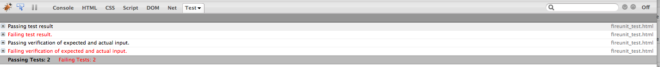
Figure 6-1. FireUnit starts out like above.

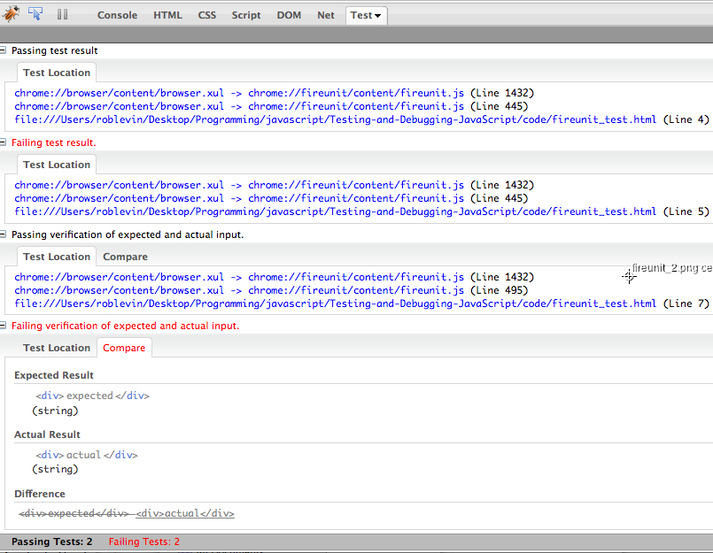
Figure 6-2. FireUnit with more detailed information after being expanded. Note the bottom test – the Compare tab has been clicked and very useful 'Difference' data is supplied.
One of the authors, John Resig, blogged about FireUnit here:
http://ejohn.org/blog/fireunit/

Jan Odvarko, one of the other authors blogs here:
http://www.softwareishard.com/blog/firebug/fireunit-testing-in-the-firebug-world/

You can actually integrate FireUnit with QUnit if you already have a test suite in the later. However, you don't get the “sexy” comparison diff described above. In any event, here's the hook you need to put in your QUnit code:
if( typeof fireunit === "object" ) {
QUnit.log = fireunit.ok;
QUnit.done = fireunit.testDone;
}

The FireUnit extension is still very much in it's beginning stages, but proves to be an exciting additional tool for JavaScript developers!

jspec
Contents:
jspec 26
7.1 Introduction 26
7.2 Installation 26
7.3 Usage 27
7.2 Additional Features 30
Callbacks 30
Options 30
Server Formatting 31
Other Tidbits 31

7.1 Introduction
Jspec is a BDD testing framework that has much in common with the Ruby BDD framework RSpec. If you are a Ruby developer coming from using RSpec (or any other BDD framework), you'll feel at home with this framework. If not, and you're in a hurry to get going, you may want to skip this chapter and come back when you're ready to experiment with BDD.

– Does this work on Linux too or just Macs??? NEED TO TEST!!!

At the time of this writing, the http://visionmedia.github.com/jspec/ site listed several screen-casts of the author, TJ Holowaychuk, which were quite helpful in getting an overview of the tool. In the screen-cast about jspec's grammar, the he states that “it is not JavaScript, but JavaScript runs it”. In fact, it looks a bit like a combination of JavaScript and Ruby.

If this bothers you, you can edit the spec.dom.html file and force it use just JavaScript. If you want to do this, please see the documentation as this is out of the scope of this document.

7.2 Installation
In order to install jspec you will first need to install the gem command line utility. If you're a Ruby developer you already have this. If not, you can get directions for installing it here:
http://docs.rubygems.org/read/chapter/3

Once you have the gem utility installed, you can issue the following command to get the jspec gem:

$sudo gem install visionmedia-jspec --source http://gems.github.com

Then you can verify it's installed with:

$ jspec --version
// On the authors system outputs: JSpec 2.11.2

Alternatively, you can manually include it from your JavaScript program, but we will use the gem for this document. You will also want to turn on the developer debugging in Safari if you plan to use it on a Mac (it defaults to opening up the results in whatever browser your environment defaults to using – but this can be overiden with the --browsers option discussed a few pages later):

$ defaults write com.apple.Safari IncludeDebugMenu 1

7.3 Usage
Jspec has a whole different way of developing in comparison to the other frameworks we've looked at so far. You actually use it to generate a minimal set of project directories a bit like you would if generating a Rails project.
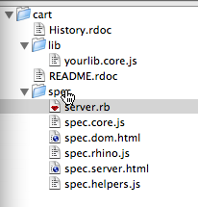
$jspec init PROJECT_NAME
$cd PROJECT_NAME

If you open the created project directory you will see something similar to the image on the right:

To start the jspec environment type:
$jspec run

On the author's MacBook, this automatically opened up the Safari browser as seen in Figure 7.1 below:

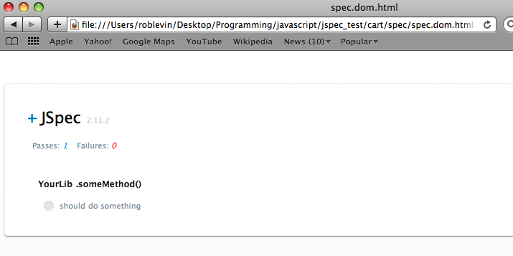
Figure 7-1. jspec run will automatically open Safari to point to the spec.dom.html as above.
This is showing a passing test because we just left the boiler plate default test. Let's do one iteration of a BDD cycle (from jspec's author's screen-casts):

- First we generate a test in the spec_core.js file (note that you can create other spec files, but we'll go ahead and use the default by deleting the boiler plate code and adding our own as follows):

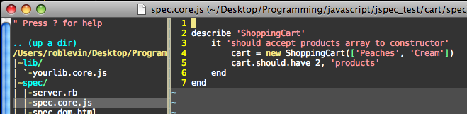
- Reload the Safari browser and see the failing test (we haven't implemented anything yet!):
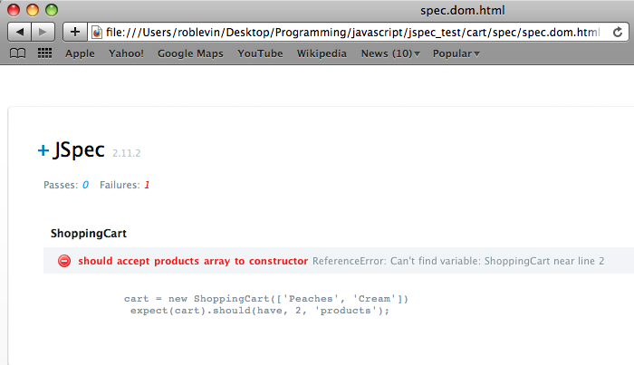
- Implement the minimal code to make this pass:

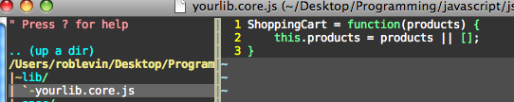
- Reload the browser once more and see it pass:
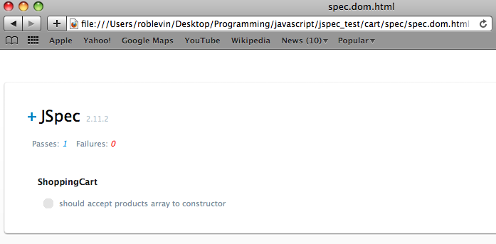
This is essentially the same introduction that the jspec author gives in the screen-casts which you might previously mentioned.

These steps show the basic flow of BDD development. To quote the official RSpec web site (an infamous Ruby BDD framework) the following steps outline an iteration of BDD:

- Start with a very simple example that expresses some basic desired behavior.
- Run the example and watch it fail.
- Now write just enough code to make it pass.
- Run the example and bask in the joy that is green.
[RSPECBDD]

The idea, is that you continue to do the above steps as you add on features, fix bugs, etc.

7.2 Additional Features
The following are some of the additional features available in jspec. For more details see the official site and/or the very detailed README file.

Callbacks
Just as the xUnit derivatives used setup and teardown, jspec has before and after hooks. There are also similar callbacks such as before_each and after_each which give you finer grained control as you'd expect. See documentation for more details on the hooks available (or better yet, the jspec.js source code itself which is pretty concise and easy to browse).

Options
It also allows you to add the '--browsers' switch to test in multiple browser:

$jspec run --browsers ff,safari

This will open up the respective browsers on your system if they're installed. You can also run the '--server' switch to see the passes and failures in your console (if you don't have a particular browser installed it will tell you it couldn't find it):

$ jspec run --browsers ff,chrome,safari --server
Started JSpec server at http://0.0.0.0:4444
Unable to find application named 'Chromium'

Firefox Passes: 0 Failures: 0
Safari Passes: 0 Failures: 0

If you leave out the browsers switch it will attempt to open all and again inform you for each one that you don't have:
$ jspec run --server
Started JSpec server at http://0.0.0.0:4444
Unable to find application named 'Chromium'
Unable to find application named 'Opera'

Firefox Passes: 0 Failures: 0
Safari Passes: 0 Failures: 0

Note that you'll need to do a Ctrl-C to end the process.

Server Formatting

You can fine tune the server settings in the spec.server.html and server.rb files. So for example, if you'd like less verbosity in your test runs you can edit the following line in spec.server.html:

.run({ formatter: JSpec.formatters.Server, verbose: true, failuresOnly: true })
to:
.run({ formatter: JSpec.formatters.Server })

and your output will be more concise. Additionally, if you have rhino installed on your system you can use the --rhino switch to run your tests through rhino.

Other Tidbits

- You can also test for a throw from within a test case as in:
function(){ throw 'some_error' }.should.throw_error 'some_error'
- Fixtures: If you need a DOM document to test on, you can create a fixture and then load it in your before or before_each hook.
- The above fixtures can be in HTML, json, XML, etc. See documentation for details.
- Not shown on the screen-shots is the rightmost side of our browser window when running the jspec tests. On our system, it shows vertical lines or “pipes”, each representing an assertion within that test case; so if you made two assertions it would show something like '||', three '|||', etc., on the right side of the jspec results page.

Summary
In this section we've taken a look at 4 testing frameworks. YUI Test, QUnit, and FireUnit are of the xUnit derivative, whereas jspec is a BDD framework much in the spirit of RSpec. There are many more JavaScript testing frameworks available. Some of the frameworks which we would have loved to included had this document been a “JavaScript testing tome”:

- JSUnit (been around for a long time and used by many projects)
- JSSpec (used by the MooTools framework)
- unittest.js (script.aculo.us and Prototype)
- JsUnitTest (based off Prototype's unittest.js)
- D.O.H. (Dojo Objective Harness)
- screw.unit (another BDD style framework)
- Jasmine (a Pivotol Lab's BDD framework)

As far as determining which one of these frameworks is right for your projects, the first thing to figure out is if you're going to go with xUnit or BDD style testing. If you're coming from a Java shop that's been using JUnit in Eclipse for ages, and have no intentions on ramping up on 'this BDD thing', than of course you've already made your decision. However, if you're a Ruby developer, it's pretty hard to escape the fact that all the “cool kids” have embraced BDD - you may want to keep things somewhat familiar by using BDD in your JavaScript testing framework. If you're of the “non-religious” derivative of programmers out there, play with both and see which feels more comfortable to you. Whichever you use you'll be better off than you were just cutting code and releasing!

Unit Tests vs. Regression Tests
One thing that you should be cognizant of, is the difference in what you gain from unit tests versus integration tests (also called acceptance tests or regression tests) - we are purposely blurring the lines between acceptance, regression, and integration testing as they are quite similar by nature but in fact different. For our purposes we'll use the terms interchangibly.

Deferring to Wikipedia:
Unit testing: 'a software verification and validation method in which a programmer tests if individual units of source code are fit for use. A unit is the smallest testable part of an application...'
Regression testing: 'any type of software testing that seeks to uncover software regressions...Typically, regressions occur as an unintended consequence of program changes. Common methods of regression testing include rerunning previously run tests and checking whether previously fixed faults have re-emerged.'
It's important to note that, although some regression-benefit may be derived from old unit tests, this is usually not the case. For example, you have a public API that must never change, but for what ever reason, you decide to “re-gut” the entire internal implementation. However, you maintain that you must not change your public API. Since you are completely changing your internal system, your unit tests may not help you test the public API at all – they probably just tested you're implementation. HIf you have a regression suite, you can benefit by 'rerunning previously run tests' to insure that your new system maintains it's public interface.

In fact, Merb is a notable piece of software (now merged into Ruby on Rails) for which this was exactly the case. [KYCTDS2008] Yehuda Katz, the lead developer and presenter of the presentation in the following link gives a very pragmatic view on the benefits of unit and integration testing: http://rubyconf2008.confreaks.com/writing-code-that-doesnt-suck.html

If this diversion has scared you, be comforted by the fact that this book will primarily use “vanilla unit tests”. Note that we will be primarily using jspec for the upcoming chapters.

Part III – Test Driving JavaScript
It turns out that unit testing is a great way to quickly grok a programming language. If an interpreter is available for language as well you may want to combine these tools by:
- using the interpreter for immediate feedback when “staying in the groove” is of the utmost importance (I.e. while you're working on a real project).
- using unit tests to explore the edges of a particular language so that you have an “automated recording” of your findings.

For JavaScript, we've already discussed a very nice interpreter – the Firebug console!

Before we get started
Note that the examples will use jspec for this section by the author's choice. If you have chosen another framework like QUnit or YUI Test, feel free to convert the examples to use that framework instead. Rest assured that, the following tests will be simple pedantic examples so transposition should be trivial.

Much of the object creation and inheritance sections can be used as supplemental study to the topics provided in Chapter 6 of Professional JavaScript for Web Developers, 2nd Edition by Nicholas C. Zakas, and Chapter 3 & 5 of JavaScript: The Good Parts by Douglas Crockford. Both of these chapters go into some interesting but quirky details of JavaScript's object creation and inheritance models. But first we'll start with some very basic JavaScript...

5 Minute Drill
Let's dive into a couple of JavaScript basics to get our bearings. If you're a guru you could skip this section but you may want to skim just to see the general concept of grokking a language via unit tests.

Getting things set up is always a challenge so here's the first steps to getting tests going using jspec (again, if you'd like to use one of the other frameworks that's fine too):
- jspec init
- Then open the created project in your IDE or editor of choice
- jspec needs to be able to find your 'system under test'. We changed that to be /lib/test_js_itself.js (instead of /lib/yourlib.core.js which we deleted)
- Run 'jspec run --browser ff' – from the console for each test run

spec.core.js

describe 'TestJsItself'
before_each
jsTest = new JSTest
end
describe '.switchTest()'
it 'should return corresponding case primitive int as a string'
jsTest.switchTest(1).should.eql "one"
end
end
end

test_js_itself.js

JSTest = function() {}
JSTest.prototype = {
constructor: JSTest,
switchTest : function(c) {
switch(c) {
case 0:
return "zero";
break;
case 1:
return "one";
break;
}
}
}

Running the above with jspec passes. If it's not obvious from context, we are testing the basic functionality of the switch statement in JavaScript. In the above, the system under test (idiomatic for the object you're testing) is the test_js_itself.js program, and the describe '.switchTest()' line is a test case that tests the switchTest() method. The 'it should' is an assertion. The .eql is a BDD “matcher”.

In the QUnit framework, a transposition of the above test case might look something like:

test("Returns corresponding case primitive int as a string", function() {
jsTest = new JSTest(); // likely moved to setup
actual = jsTest.switchTest(1); // calls the 'sut' system under test
same(actual, "one", "Returns corresponding...as a string"); // assertion
});

Note that we did not test the above code so consider it pseudocode! Other xUnit family frameworks might use something like assertSame or assertEquals.

By writing both the test case for switchTest and the method implementation of switchTest itself, we've jumped ahead of the TDD process – normally we would: 1) write the test 2)watch it fail 3) implement the code 4) rerun the test and watch it pass.

So we've confirmed that we understand the basics of how a switch statement works in JavaScript. But how about the venerable fall-through. We hypothesize that omitting a break means that it will fall-through to the next case. Moreover, we've heard that JavaScript allows us to combine primitives and reference types in the case statements. We add the following in bold to our test:

describe '.switchTest()'
it 'should return corresponding case primitive int as a string'
jsTest.switchTest(1).should.eql "one"
end
it 'should fall through to next case when omitting a break'
jsTest.switchTest("no break case") "next case"
end
end

Running this I get an error:

TypeError: actual is undefined

Although it's a bit hard to tell from that message, we know that we haven't even defined the corresponding case in our switch statement, so jspec is choking. We add the bold section to our switch:

switch(c) {
case 0:
return "zero";
break;
case 1:
return "one";
break;
case "no break case":
// do nothing...testing fall through
case "next case":
return "next case";
break;
}
}

It passes. We've proved that fall through works as expected (and that we can mix and mash Number types with String types, etc.) 'Big deal' you say. Hold on, things will get more interesting soon!

Are we confident enough in creating simple vars? For example:
var x =1; var y = 2; result = x + y; // result == 3 Of course we are. No need to test that!

Let's have a look at creating Arrays. We'll check for creation and that indexing is zero based. So we add a test:

describe '.arrayTest()'
it 'should create an array and index by zero based subscripts'
arr = jsTest.arrayTest()
(arr.class == 'Array').should.eql "true"
end
end

When we run jspec we get the following error:
TypeError: jsTest.arrayTest is not a function

Great! We've created a test, watched it fail (because there's no implementation yet) – we're doing TDD development! So we add the following remembering to place a comma after our switchCase method:

arrayTest : function() {
return [1,2,3,4,5];
}

it fails: expected false to eql 'true'

Ah right, we accidentally tried using .class because we were thinking in Ruby not JavaScript – ouch! So we remember that there's a typeof operator in JavaScript for this sort of thing. Before going back to the test, we open up Firebug because we're a bit unsure of ourselves and need some instantaneous feedback:

typeof [1,2,3] == "array"; // false, huh???
arr = [1,2,3];
typeof arr == "array"; // false, what the heck?
arr = new Array(1,2,3);
typeof arr == "array"; // false
typeof [1,2,3] == "object"; // true, oh yeah Crockford said something about this!

Upon doing this of course we realize that JavaScript returns “object” for Arrays and recollect Douglas Crockford mentioned something about this. Sure enough we Google: 'typeof javascript array' and his page comes up first:
http://javascript.crockford.com/remedial.html

Ok, so we'd already heard about this problem but still forgot – oh the shame! How can we make sure we don't forget next time? Well, now that we know the rule lets change our test. In fact, let's break this up into two cohesive tests – one to confirm that typeof array returns “object” and another for our original claim that array's in JavaScript use zero based indexing:
...
describe '.arrayTest()'
it 'should return object for typeof array because JS is weird in that way'
typeof arr == 'object' // uh oh! No matcher should.eql
end
it 'should use zero based indexing'
arr[1].should.eql 2
end
end
...

Interestingly, jspec now shows that we have three of the tests passing out of four - jspec shows that something's went wrong with the third test. Right, we forgot to use a matcher (eg should.eql). It doesn't explode but the test doesn't end up doing anything. So we change the bold line from above to read:

(typeof arr == 'object').should.eql true

We run jspec and we get: 'Passes: 4' – cool!

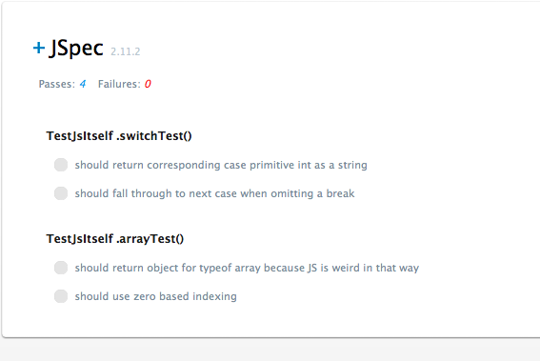
Figure 8-1. We've used TDD development to test JavaScript's switch statement and Array data structure. After some initial misconceptions, we've managed to finally make all the tests pass!
We've only tested a couple of areas of JavaScript but we've already cataloged an interesting JavaScript oddity – the way typeof returns 'object' on Arrays (it does this with nulls too!). Next we could exercise some of the Array methods like sort, push, etc., just to confirm our understanding. This would take just minutes but our tests would live on for later reference. Here's a helpful page for doing just that:
https://developer.mozilla.org/en/Core_JavaScript_1.5_Reference/Global_Objects/Array

What just happened?
The above exemplifies the process of using test driven development to confirm a language's rules and syntax. The mistakes and fumbles along the way were left in because they realistically show the mindset used to deal with road blocks.

Two other popular ways of experimenting with a language are: using an interpreter for instant feedback (useful in it's own right), and writing small test programs. Small test programs are not very effective to aid in recalling concepts later – you end up with either a rats nest of small programs which become hard to later find, or one jumbled file virtually impossible to navigate.

As unit tests are, by design, meant to be self documenting, they will provide a means for future reference that won't “hurt your eyes”. If you want to be able to grep the files later, there's nothing stopping you from adding easy-to-grep comments like /* ARRAY_TESTS */ allowing you to do:
grep -A 10 'ARRAY_TESTS' my_tests.js
to get the 10 lines after the matching ARRAY_TESTS section.

Next we look at some interesting areas of JavaScript that the author encountered reading both the Zakas and Crockford books – namely Object Creation and Inheritance.

Objects
Contents:
Objects 38
Object Creation 38
Accessing Object Properties 40
Object Assigned by Reference 40
Prototypes 41
Prototype Shadowing 42
Reinventing Thyself 42
Prototype Issue 43

This chapter will deal with JavaScript objects and will use unit tests confirm our understanding of how they work. The author will examine interesting topics from Chapter 3 & 5 of JavaScript: The Good Parts – Douglas Crockford, and Chapter 6 of Professional JavaScript for Web Developers, 2nd edition – Nicholas Zakas.

Object Creation

So let's get right into creating objects with object literals. Our test:

describe 'JSObjects'
before_each
jso = new JSObjects();
end
describe '.objLiteralCreate()'
it 'should create an object literal'
(typeof jso.objLiteralCreate() == 'object').should.eql true
end
end
end

We run our test in jspec and of course get the fail as there's no implementation:
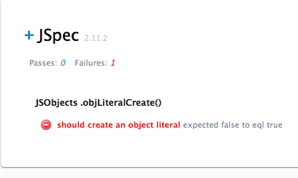
Figure 8-2. Step two in TDD is to run your unimplemented test which will inevitably fail!
So we implement the following in our system under test:

function JSObjects(){};
JSObjects.prototype = {
constructor : JSObjects,
objLiteralCreate : function() {
return {
name : 'Rob',
age : 39
}
}
}

And we pass:
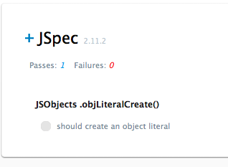

Figure 8-3. Steps 3 & 4 our respectively: implement the feature, watch it pass

There's a bit of extra stuff going on in that implementation but it essentially does the following:

function JSObjects(){};

Creates a constructor for our system under test JSObjects.

JSObjects.prototype = …

JavaScript is a prototypal language meaning that it provides a “prototype linkage” allowing one object to inherit properties and methods from another. [CDJGS20] Suffice it to say that this is preferable to adding methods directly into a constructor which would cause method objects to be created for each instance.

Our return statement creates and returns an object literal which is essentially a grouping of
name : value pairs within brackets {} where the names can represent either properties or methods. This notation is very convenient and visually helpful. However, we could have also done this using the new Object() constructor and dot notation like so:

o = new Object();
o.name = 'Rob';
o.age = 39;
return o;

In fact, I tested this by commenting out the object literal return statement and adding the above.

Accessing Object Properties
JavaScript can use either dot or subscript notation to access properties:

describe 'Accessing Object Properties'
it 'should be able to use either dot or subscript notation for access'
o = {name:'Rob', age:39}
o.name.should.eql 'Rob'
o['name'].should.eql 'Rob'
end
end

Note that we did something a bit different here – instead of calling a method on our system under test, we just tested the feature from right within our test case. Since we're simply testing language features this is perfectly acceptable.

Object Assigned by Reference
Objects are assigned by reference and not copied [CDJGP22]:

describe 'Object Assignment'
it 'should reference original object and reflect any changes made to original'
o = jso.objLiteralCreate();
var copy = o;
copy.name.should.eql 'Rob'
o.name = 'Charlie'
copy.name.should.eql 'Charlie'
end
end

So once we change the original we see the changes in the variable that was assigned to ('copy' is probably a bad variable name here because we've just proved it's not a copy but a reference! 'ref' would be a much better variable name). In any event, we get a pass.

Prototypes
Prototypes are useful in that you can add properties to an object, and those properties will be shared by all instances of that object. Alternatively, you can define properties in an object's constructor, but doing so means that you have to create these properties for each instance created. That's fine for instance variables but for methods (which are essentially JavaScript functions) remember that functions are objects. So if I have 1 method defined in my constructor, and then instantiate that constructor 5 times, I will have created 5 method objects (one for each instance). This can get quite memory intensive if you need a non-trivial collection of such objects. Therefore, the idiom is to define such methods in a prototype which will be shared by all instances.

<--- PROTOTYPE DIAGRAM NEEDED HERE --->

Prototypes are also a means for achieving inheritance in JavaScript, and we will discuss that aspect of prototypes more in the chapter on Inheritance. For now, let's take a look at how prototype properties work with objects and their instances. We hypothesize that prototype properties are shared by instances:

describe 'ObjectCreation'
before_each
function MyObj(){};
MyObj.prototype.foo = 'foo property';
MyObj.prototype.bar = function() { return "me is bar method"; }
obj1 = new MyObj();
obj2 = new MyObj();
end

describe 'Prototypes and Object Creation'
it 'should add prototype property which should be available to all instances'
obj1.foo.should.eql 'foo property'
obj2.foo.should.eql 'foo property'
obj1.bar().should.eql 'me is bar method'
obj2.bar().should.eql 'me is bar method'
end
end
end

Above, we created an object constructor on the first line of the before_each hook, added two prototypal properties, one an instance variable of MyObj and the other a method of MyObj. Lastly, we create two instances. In our test case, we assert that for each instance both properties are available. This test passes. This begs the question “What if we manually overwrite a prototype property? Does it affect all instances?” Let's see...

Prototype Shadowing
If we create a case like:

obj1.foo = "new version of foo"
obj2.foo.should.eql "new version of foo"

It fails because obj2 still has the old prototype value (“foo property”). Therefore, this does work:

it 'should update a prototype property but only affect that same instance'
obj1.foo = "new version of foo"
obj1.foo.should.eql "new version of foo"
obj2.foo.should.eql "foo property"
end

“Ok, well are we really updating the property or just shadowing it?”. Let's test this by updating a property, deleting the updated property, then checking again to see if original prototype value shows itself again [ZNPJWD158]:

describe 'Updated Prototype Props are really shadowed'
it 'should return to showing original prototype value after deleting shadow'
obj1.foo = "new version of foo"
obj1.foo.should.eql "new version of foo"
delete obj1.foo;
obj1.foo.should.eql "foo property"
end
end

That's interesting! When we delete the updated property, the prototype version of the property shows up again! Let's check if prototype methods exhibit the same shadow behavior:

obj1.bar = function() { return "me is NEW bar method!"; }
obj1.bar().should.eql 'me is NEW bar method!'
delete obj1.bar;
obj1.bar().should.eql 'me is bar method'

It's as if we put a layer in front of the original prototype method when we assigned the “me is NEW bar...” version. It's very important to note that the original did not go away as shown above! Hence, we say it's shadowed.

Reinventing Thyself
You can completely overwrite the default prototype and use a prototype literal. In fact, since you can add all of the additional properties at once, it makes visual sense to do so:

js_obj_creation.js

function FancyProto(){}
FancyProto.prototype = {
constructor : FancyProto, // instance.contructor will == Thing and not Object!
x : 100,
y : 200,
foo : function() { return "I am foo"; }
};

function SloppyProto(){}
SloppyProto.prototype = {
//constructor : SloppyProto // instance.contructor will now be Object
name : 'Sloppy Joe'
};

Above, we've commented out the constructor field in SloppyProto so calls to sloppyInstance.constructor will equal Object. In our test we can see this is in fact the case:

it 'should have constructor field if needs it to be available to instances'
t = new FancyProto();
t.foo().should.eql 'I am foo'
(t instanceof FancyProto).should.eql true
(t.constructor == FancyProto).should.eql true
s = new SloppyProto();
(s.constructor == SloppyProto).should.eql false
(s.constructor == Object).should.eql true
end

Note that when we overwrite the prototype we must be sure to do so before creating instances. If not, the instances will just point to default prototype and we'll get an error as soon as we try to access the properties of the new prototype [ZNPJWD163]:

it 'should be that instances created before overwriting prototype point to old default prototype so new prototype properties WILL NOT be available'
function Thing(){}
var beforeProto = new Thing();
Thing.prototype = {
foo : 'foo'
};
('foo' in beforeProto).should.eql false
var afterProto = new Thing();
('foo' in afterProto).should.eql true
end

Above, we create instances before and after overwriting the prototype. We can see in the highlighted lines that the beforeProto instance does not have access to the foo method but the afterProto instance does as this test passes. Note that if we had actually called the foo method on beforeProto we would recieve an error.

Prototype Issue
Putting stuff in prototypes is great because it saves memory. Agreed. But this shared state is not so great for reference properties. The reason this is not a great thing is that the state of these reference properties gets shared between all instances. Java and many other languages call this behavior static.

There's an odd caveat that's frankly hard to memorize – primitive types seem to work just fine – it's reference types like Arrays and Objects that exhibit static behavior! The author uses an imperative heuristic: “Never put non-methods in prototypes!” Let's examine this through code. Given the following object:

function Issues(){}
Issues.prototype = {
x : 1,
arr : ['uno','dos','tres'],
hsh : {phone : 'iPhone', carrier : 'ATT' }
}

We then test the prototype-static-issue on the primitive, Array, and Hash defined:

describe 'Prototype Issue - Static-Like Behavior ONLY for Reference Types'
it 'should share state on prototype non-method properties'
var instance1 = new Issues()
var instance2 = new Issues()

// Reference types are essentially static
instance1.arr.push('cuatro')
(instance1.arr === instance2.arr).should.eql true

instance1.hsh['phone'] = 'Blackberry'
(instance1.hsh === instance2.hsh).should.eql true
i2Phone = instance2.hsh['phone'].should.eql 'Blackberry'

// OMG, primitives hide their state just fine!
instance1.x = 9
instance1.x.should.eql 9
instance2.x.should.eql 1
end
end

The salient point to remember here is: prototype primitives do hide state and act like “non-statics” whereas reference types act like statics and therefore do not hide their state.

The convention is to put methods in the prototype and put the object's properties in the constructor thus combining the constructor and prototype patterns. According to Nicholas Zakas [ZNPJWD166]:

'The hybrid constructor/prototype pattern is the most widely used and accepted practice for defining reference types in ECMAScript.'

By doing this, you will retain the integrity of your object properties between instances, while saving memory creating method objects just once to be shared by all instances.

If you are more comfortable with having all of your object creation code in the constructor, you can place the prototype definition directly in the constructor with a conditional to insure that it only gets created one time:

if (typeof this.someProtoMethod != “function”) {
// Define your prototype methods here
}

In summary, we have taken a look at object creation details such as:
- object creations through the literal and new Object() idioms
- object references (namely that they are passed by reference not copied)
- many aspects of prototypes relating to object creation
There's a somewhat hazy distinction between object creation and inheritance – you can't inherit anything unless you've creating something to inherit from in the first place. Because of that coupling, we have purposely deferred the discussion of concepts like durable object to the next chapter.

Inheritance
Contents:
Inheritance 45
Pseudoclassical 45
Prototype Shared State Issue 47
Constructor Stealing & Combination Inheritance 47
Prototypal Inheritance 48
Inheriting Prototypes Not Constructors 49
Functional Inheritance 50
Summary of Inheritance Patterns 52

Let's start by discussing what Douglas Crockford calls the Pseudoclassical style of inheritance.

Pseudoclassical
The main characteristics of the pseudoclassical style of inheritance are that we combine constructor and prototype definitions on our parent object (this is more or less the same as what Zakas calls a hybrid constructor/prototype pattern as discussed in the last chapter. His version just explicitly specifies that instance variables go in the constructor and methods in the prototype. Crockford's 'mammal' example on page 47 of JavaScript: The Good Parts basically follow this pattern as well [CDJGP47]). Then we create a child object and manually connect it to the parent by overwriting it's prototype and pointing that to the parent object. Let's have a look.

First we make sure we can create the parent object and instantiate it successfully. First the failing test gets written and ran (in /code/spec/spec.js_inheritance.js):

describe 'Pseudoclassical Inheritance Creation'
it 'should create parent and child objects using pseudoclassical style'
// First part: create a parent object and successfully instantiate it
var onyx = new Animal("Onyx")
onyx.whoAmI().should.match /I am Onyx.*/

// More to come...
end
end

ReferenceError: Animal is not defined

Then we implement the code to make it pass:

function Animal(name){
this.name = name;
}
Animal.prototype = {
whoAmI: function() { return "I am " + this.name + "!\n"; }
};

Notice that we have used the 'match' regex matcher which gives us regex capabilities. There's no reason to try to remember (or match) on '!\n' so regex works nicely here. Next is to create the child object and connect its prototype to the parent object (Animal).

function Dog(name, breed) {
this.name = name;
this.breed = breed;
}
Dog.prototype = new Animal();
Dog.prototype.getBreed = function() {
return this.breed;
}
Dog.prototype.bark = function() {
return 'ruff ruff';
}

We start out be creating a Dog constructor that takes an additional property 'breed'. Then we augment the Dog with the getBreed and bark methods (jumping ahead of ourselves again!). In any event, the initial test passes. Then we decide to test the heck out of the instance and constructor relationships:

it 'should create parent and child object using pseudoclassical inheritance'
animal.constructor.should.eql Animal
// dog.constructor.should.eql Dog // Nope: expected Animal to eql Dog
dog.constructor.should.eql Animal
animal.should.be_a Animal
dog.should.be_a Animal
// dog.should.be_a Dog // Nope!
// We severed the original prototype pointer and now point to Animal!
dog.should.be_an_instance_of Animal
dog.should.be_an_instance_of Dog
(animal instanceof Dog).should.be_false
end

This is a rather verbose test! It doesn't matter since we're merely testing our understanding of the language, but in a real application we'd probably do away with half the assertions that essentially add code duplication.

The bold lines show that prototypal inheritance has a quirk in that the derivative object's constructor points to the parent (so Dog's constructor points to Animal). The constructor essentially becomes useless to us at runtime in the pseudoclassical pattern.

Both the whoAmI method and the name instance variable are defined in the parent class but become available to the child as expected:

it 'should behave such that child inherits methods and instance variables defined in parent'
animal.whoAmI().should.match /I am Onyx.*/
dog.whoAmI().should.match /Sebastian.*/
animal.should.respond_to 'whoAmI'
dog.should.respond_to 'whoAmI'
dog.should.have_prop 'name'
end

Prototype Shared State Issue
The issue of shared state was already brought up in the last chapter on object creation – when we created reference types in the prototype, instances shared the state. Well this time we put a reference type in the constructor, but because the child's prototype now points to the parent's constructor, we end up with the same type of issue – the following shows this:

First we add the following to our Animal constructor:

this.arr = [1,2,3];

Again, recall that at a certain point we essentially do: Child.prototype = new Parent() so the child's prototype will inherit the above 'arr'. Now all instances of the child will share the state! Here's an example of the potential mess created:

it 'should behave such that reference variables on the parent are "staticy" to all child instances'
dog.arr.should.eql([1,2,3])
dog.arr.push(4)
dog.arr.should.eql([1,2,3,4])
spike = new Dog("Spike", "Pitbull")
spike.arr.should.eql([1,2,3,4])
spike.arr.push(5)
rover = new Dog("Rover", "German Sheppard")
spike.arr.should.eql([1,2,3,4,5])
rover.arr.should.eql([1,2,3,4,5])
dog.arr.should.eql([1,2,3,4,5])
end

We have our original 'dog' instance, and add 'spike' and 'rover' to the mix. Being the spunky canines that they are, each one pushes another element in to the 'arr'. By the last three bolded lines they can all see the changes made. It's easy to see what's happening here, but what these types of changes were made in various parts of a big program? It would be very likely that side effects would get introduced, because there's no encapsulation left!

Constructor Stealing & Combination Inheritance
Constructor stealing allows the child to call the parent's constructor. A single line of code is added in the sub-type constructor that calls the parent-constructor with the appropriate properties. So if we had Parent and Child signatures as follows:

function Parent(name)
function Child(name, age)

The Child constructor would add a line like:

Parent.call(this, name)

By using the 'call' method on the Parent object, we pass this (the newly created Child instance) to the Parent's constructor. By doing so, the Parent constructor now executes with the Child instance as the current object. Since the current object is what gets acted on in any public function, the Child instance essentially gets constructed to “be an” Animal. Note that we don't pass in age because that's a property that's left unique to Child objects.

The net result is that we get the benefits of prototype chaining while maintaining encapsulation by adding constructor stealing to the mix. The pattern of combining these two is called combination inheritance [ZNPJWD176]. When we create instances of the Child they will each keep there own state.

The following is both the implementation and test for combination inheritance:

// Combination Inheritance
function Parent(name) {
this.name = name;
this.arr = [1,2,3];
}
Parent.prototype = {
constructor: Parent,
toString: function() { return "My name is " + this.name; }
}
function Child(name, age) {
this.age = age;
Parent.call(this, name);
}
Child.prototype = new Parent();
Child.prototype.getAge = function() {
return this.age;
}

And the test:

describe 'Combination Inheritance Solves Static Prototype Properties Issue'
it 'should maintain separate state for each child object'
child_1 = new Child("David", 21)
child_2 = new Child("Peter", 32)
child_1.getAge().should.eql 21
child_1.arr.push(999)
child_2.arr.push(333)
child_1.arr.should.eql([1,2,3,999])
child_2.arr.should.eql([1,2,3,333])
child_1.should.be_a Parent
end
end

The bold lines above show that even though each instance altered the 'arr' reference type, the changes were encapsulated within both instances. Unfortunately, our Child is a Parent which is sort of correct but not very useful to us later if we need to later determine it's type. Another complaint some make is that this pattern requires calling the Parent constructor twice: once in the constructor stealing Parent.call line, and next for the prototype chaining Child.prototype = new Parent(). We'll see later a trick to use a helper to chain the prototype's directly later in this chapter.

Prototypal Inheritance
Prototypal inheritance is another simple inheritance option if we don't need to impose strict access. It depends on the availability of a helper function to attach a new object to another parent object:

Object.prototype.inherit = function(p) {
NewObj = function(){};
NewObj.prototype = p;
return new NewObj();
}

There's of course nothing requiring you to monkey patch Object – you can create a wrapper that returns such functionality and keep Object's namespace “clean”. In fact, we've altered the code that follows to use such a wrapper object.

We tap into the simple stubbing functionality in jspec to create a person object at the beginning of our tests, by putting the following in a before hook:

person = { password : 'secret', toString : function(){ return '<Person>' } }
stub(person, 'toString').and_return('Original toString method!')

and then use it in our test:

describe 'Prototypal Inheritance'
it 'should inherit properties from parent'
person.toString().should.match /Original toString.*/i
person.password.should.eql 'secret'
joe = helper.inherit(person)
joe.password.should.eql 'secret'
joe.password = 'letmein'
joe.password.should.eql 'letmein'
person.password.should.eql 'secret'
end
end

Don't use this pattern when privacy is needed. Notice that our child object 'joe' inherits the person password? This may or may not be what you want, but you should be cognizant of the behavior. The nice thing is you didn't have to create two distinct constructors for super and sub types, but you still managed to make the instances “behave like” a Person.

Inheriting Prototypes Not Constructors

On page 181 of Professional JavaScript for Web Developers, 2nd edition, Nicholas Zakas essentially provides the following Parasitic Combination Inheritance pattern which utilizes a helper function for inheriting prototypes [ZNPJWD181]:

// Prototypal Inheritance
var helper = { // Thanks to Bob Vince for reminding me NOT to clobber Object!
inherit: function(p) {
NewObj = function(){};
NewObj.prototype = p;
return new NewObj();
},
inheritPrototype: function(subType, superType) {
var prototype = helper.inherit(superType.prototype);
prototype.constructor = subType;
subType.prototype = prototype;
}
};

function SubType(name, age) {
Parent.call(this, name);
this.age = age;
};
//Child.prototype = new Parent(); // Gets replaced by:
helper.inheritPrototype(SubType, Parent);
SubType.prototype.getAge = function() {
return this.age;
};

And here's our test:

describe 'Parisitic Combination Inheritance'
it 'should use inheritPrototype (to call parent constructor once) and still work as expected'
sub = new SubType("Nicholas Zakas", 29)
sub.toString().should.match /.*Nicholas Zakas/
sub.getAge().should.eql 29
charlie = new SubType("Charlie Brown", 69)
charlie.arr.should.eql([1,2,3])
charlie.arr.push(999)
charlie.arr.should.eql([1,2,3,999])
sub.arr.should.eql([1,2,3])
sub.should.be_an_instance_of SubType
charlie.should.be_an_instance_of SubType
(sub instanceof SubType).should.eql true
(sub instanceof Parent).should.eql true
end
end

We create two SubType instances, 'sub' and 'charlie'. We push an element on the 'arr' charlie inherited, and test to see if both instances can see the change. The '999' element only is available on to charlie's version of 'arr', so our references are not exhibiting static nature! Moreover, our instanceof appears to be working correctly as well. Notice the code duplication? I just wanted to be sure that jspec's be_an_instance_of matcher was working as expected, and in fact testing instanceof behind the scenes.

According to Nicholas Zakas, this pattern is used for the YUI's YAHOO.lang.extend() method. [ZNPJWD181]

Functional Inheritance

Douglas Crockford introduced a pattern of object creation and inheritance that does not use the this or new and has the ability to keep data private. He calls such objects durable because they cannot be compromised. A durable object does not provide access to its internal state (even if one has access to the durable object itself). [ZNPJWD169][CDJGP52]

First we will create a durable super object and test that it works as expected while keeping it's variables hidden. First the test:

describe 'Functional Durable Inheritance'
it 'should hide private variables'
sub = new SuperFunk(
{name: "Superfly", age: 39, foo: "foo", bar: "bar"} )
sub.getName().should.eql 'Superfly'
sub.name.should.be_undefined
sub.getAge().should.eql 39
sub.age.should.be_undefined
sub.getFoo().should.eql 'foo'
sub.foo.should.be_undefined
end
end

Here is the implementation of the super object:

function SuperFunk(blueprint) {
var obj = {};
obj.getName = function() { return blueprint.name; };
obj.getAge = function() { return blueprint.age; };
obj.getFoo = function() { return blueprint.foo; };
obj.getBar = function() { return blueprint.bar; };
return obj;
}

Direct access to the private variables (name, age, foo, bar) does not even appear to be defined to the outside would and is, in fact, private. Now let's do the inheritance part – we create a test and implementation that 'should create a descendent object that inherits properties while maintaining privacy':

it 'should create descendent obj inherits props while maintaining privacy'
sub = new sub_func(
{name: "Submarine", age: 1, foo: "food", bar: "barfly"} )
sub.getName().should.eql 'Submarine'
sub.name.should.be_undefined
sub.getAge().should.eql 1
sub.age.should.be_undefined
sub.getFoo().should.eql 'food'
sub.foo.should.be_undefined
sub.getBar().should.eql 'barfly'
sub.bar.should.be_undefined
sub.coolAugment().should.match /.*fresh new perspective.*/
//sub.should.be_an_instance_of super_func NOPE!
//sub.should.be_an_instance_of sub_func NOPE!
sub.should.be_an_instance_of Object
end

So we need the sub object implementation:

function sub_func(blueprint) {
blueprint.name = blueprint.name || "Crockford's Place";
supr = super_func(blueprint);
supr.coolAugment = function() { return "I give a fresh new perspective on things!" };
return supr;
};

So again, we don't get the instanceof functionality. At this point, you may be asking yourself - “Do I always need reflection capabilities?”...um, we are too! Ok, that's a bit facetious; sometimes you really do want nice instanceof. If so, go back and implement the Parasitic Combination Inheritance pattern we discussed previously. However, the Durable or Functional pattern gives us a big win in the security department!

Summary of Inheritance Patterns
JavaScript gives us a lot of choices when it comes to how we want to implement inheritance! Which one you choose to use should take in to account the strength and weaknesses of that pattern. Sometimes you may know in advanced that you're only going to need shallow inheritance trees and don't care about the instanceof capabilities, or whether your constructor points to something useful. In this case, Prototypal Inheritance may work just fine. Or perhaps you're getting a project started and you know that the developers are you going to be much more productive if they have some familiar capabilities (e.g. instanceof reflection, classical looking inheritance model, etc.). Perhaps you may want to go with the Parasitic Combination Inheritance pattern. Security important? Go with Functional (Durable) Inheritance. There are many other patterns you could find on the web that may suite your needs even better. However, we've shown a pretty exhaustive list so you should be in “good shape” to make a decision for your project.

The following is a table that summarizes the strengths and weaknesses of these patterns:
Table 1-1. JavaScript Inheritance Patterns
Pattern | Strengths/Weaknesses
Pseudoclassical | Pros: Simple, Conventional.  Cons: Staticy references. Can't call parent constructor.
Combination Inheritance | Pros: Familiar Pattern. Non-staticy references.  Cons: Calls parent constructor twice.
Prototypal Inheritance | Pros: Very Simple. Good when you don't care about 'instanceof'.  Cons: Staticy references. 'instanceof' and constructors not useful.
Functional Inheritance (Durable Objects) | Pros: Privacy/Security. Good when you need durable tamper-proof instance variables.  Cons: 'instanceof' and constructors not useful.
Parasitic Combination Inheritance | Pros: Very clean and efficient. Non-staticy references. Constructor stealing. Only one constructor call.  Cons: Complicated (two helper methods required: create_object and inherit_prototype).

JavaScript Gotchas
Contents:
JavaScript Gotchas 53
Namespace 53
parseInt 53
Equality and == vs === 54
Reserved Words in Object Literals 55
Scope 56
Privileged Singleton 57

Namespace
One issue inherent in JavaScript is that top-level variables belong to the global namespace. Thus, this can cause problems such as name collisions in content heavy sites like mash-ups. Start combining libraries, advertising subscripts, etc., and you've got a real problem on your hand. One solution to the name-spacing issue is to create an application wide object literal on the global namespace and then put all your stuff in there. For example, your name is John Jacob Smith and you're designing an application for ABC Inc. You could create the following namespace:

var JJS = {};
JJS.ABC = {};

With this in place, you can then attach your objects, functions, etc., to the JJS.ABC object like:
JJS.ABC.Obj = { … }
JJS.ABC.Func = function(){ … }
etc.

[DDNSPACING][ZNPJWD645]

parseInt
The parseInt function parses a string and return an integer. It allows you to provide and optional radix as a second argument for: binary (base 2), octal (base 8), decimal (base 10), hex (base 16), by specifying the base like parseInt("1000",2) which would produce the binary converted version of “1000” converted to integer, 8.
The ECMA-262 3 Standard defines the following caveats:
'parseInt may interpret only a leading portion of the string as an integer value; it ignores any
characters that cannot be interpreted as part of the notation of an integer, and no indication is given that any such characters were ignored.

When radix is 0 or undefined and the string's number begins with a 0 digit not followed by an x or X, then the implementation may, at its discretion, interpret the number either as being octal or as being decimal. Implementations are encouraged to interpret numbers in this case as being decimal.' [ECMA3-ParseInt]

Obvious implications are:
- particular implementation may discard anything after first non-integer
- 08 and 09 will not be interpreted as decimals and are not valid octal – returns 0!
Let's write the tests:
describe 'parseInt Weirdness'
it 'should ignore any non-integer chars & discard after first non-integer'
gotchas.callParseInt('82I_AM_IGNORED_1234', 10).should.eql 82
gotchas.callParseInt('82#$I_AM_IGNORED_1234', 10).should.eql 82
gotchas.callParseInt('1010_binary_too!_1234', 2).should.eql 10
end
it 'should return zero for 08 and 09'
gotchas.callParseInt('08', undefined).should.eql 0
gotchas.callParseInt('09', undefined).should.eql 0
gotchas.callParseInt('09').should.eql 0
gotchas.callParseInt('09000', undefined).should.eql 0
gotchas.callParseInt('090jibberish00', undefined).should.eql 0
gotchas.callParseInt('08', 10).should.eql 8
end
end
We'll save space by omitting the callParseInt implementation as it just calls parseInt behind the scenes. The fact that non-integers are discarded is not so bad, but inadvertent octal issue in the second assertion (especially the bold line) shows that we should always supply the base 10 radix to insure decimal behavior if that's what we want.

Equality and == vs ===
To test for equality, JavaScript has both double equals operators: == and !=, and triple equals operators: === and !==. You should pretty much always use the === family of operands because the double equals == tries to do type coercion. The type coercion rules are complex, and as Douglas Crockford asserts, “unmemorable”. Here are some examples extracted from JavaScript: The Good Parts, page 109, and put in jspec test format:

describe '== type coercion example from Crockford Good Parts'
it 'should show that double equals type coercion is complicated and "unmemorable"'
('' == '0').should.eql false
(0 == '').should.eql true
('0' == 0).should.eql true
(false == 'false').should.eql false
(false == '0').should.eql true
(false == undefined).should.eql false
(false == null).should.eql false
(null == undefined).should.eql true
(' \t\r\n ' == 0).should.eql true
end
end
[CDJGP109]
Just type in the extra character and don't worry about the above rules!

Reserved Words in Object Literals
JavaScript has a “boat-load” of reserved words which you can find easily on the web but at the time of this writing:
http://javascript.crockford.com/survey.html
There are some oddities in the way JavaScript restricts the use of these reserved words. Namely, object literals cannot use a reserved word as a name (in a name:value pair)...or can it? Interestingly, Firefox 3.5.3 on a Mac did not complain and this passed, whereas Safari 4.0.3 choked and gave a 'parse error' in the Web Inspector's JavaScript error console. When we commented out this test, all other tests succeeded proving that this test caused the issue.
describe 'reserved words in object literals'
it 'should not allow reserved words to be used as names in object literals'
var obj = {
case: 'case',
return: 'return'
};
obj.case.should.eql 'case'
obj.return.should.eql 'return'
end
end

However, enclosing the reserved word names in quotes, and using subscript notation to access the object properites worked:

it 'should not allow reserved words to be used as names in object literals'
var obj = {
'case': 'case',
'return': 'return'
};
obj['case'].should.eql 'case'
obj['return'].should.eql 'return'
end

If for some reason you need to use a JavaScript reserved word, you should use the above strategy to prevent inconsistent behavior between browsers.

Scope
JavaScript has function scope but not block scope. This means that vars defined in your loops and conditionals (from within a function) are visible after the loop or conditional is finished executing:
function foo() {
for(i=0; i<5; i++) {
console.log(i);
}
console.log("i after running for loop is: ", i); // return 5
}
foo();

The above code prints 5 as the 'I' variable is still visible outside the for block. This is very odd to most programmers coming from other formal languages. There's a trick to get around the “no block scope” rule if you need it – you can wrap your block inside an anonymous function that calls itself. [ZNPJWD192] Since functions do provide their own scope, you will achieve the desired result:
describe 'block scope workaround'
it 'should use anonymous function to mimic block scope'
function foo() {
try {
(function() {
for(var i=0; i<5; i++) {
console.log(i);
}
})();
return i;
} catch(e) {
return "ReferenceError caught";
}
}
foo().should.eql "ReferenceError caught"
end
end

The above code is unfortunately complicated by the try/catch, but this is the only way we could get the test to run (jspec's should.throw_error didn't seem to help us). Essentially, the bold code shows that our line attempting to return i – no longer visible outside the anonymous function that wraps the for loop – will cause a error.
The reason that the function is preceded by an open parenthesize, is that the interpreter will assume a function declaration without it (a function expression is what we're after). We can actually use this same self-calling anonymous function to create a singleton with private properties. The next section covers just that.

Privileged Singleton
In order to get privacy in JavaScript, you can use the Privileged Singleton (aka Module) Pattern:

var SomeObject = {
foo: 'foo',
bar: 'bar'
};

var privileged_singleton = function() {

// Define some private members
var privateVar = 'this is private';
function privateFunc() {
return 'top secret';
}

// Create an object and augment it
var obj = SomeObject;
obj.publicVar = 'this is public';

// Privileged method has access to private members
obj.publicFunc = function() {
var message = 'publicFunc is privileged, and hereby allows you to see private var: ' + privateVar + ', as well as see the return value of privateFunc: ' + privateFunc();

return message;
};

return obj;
}();

Here's the test:

describe 'Priveleged Singleton Pattern (also called Module Pattern)'
it 'should create a singleton with private members'
privileged_singleton.privateVar.should.be_undefined
privileged_singleton.privateFun.should.be_undefined
privileged_singleton.publicFunc().should.match /publicFunc is.*this is private.*top secret/i
privileged_singleton.publicVar.should.eql 'this is public'
privileged_singleton.foo.should.eql 'foo'
end
end

Notice that the private members are undefined, and that the public function has access, and can return private data through it's privileged relationship within the function. Moreover, we have access to both the original object properties (originally defined on SomeObject) and the augmented properties (e.g. publicVar and publicFunc).
There are other gotchas in JavaScript such as bitwise manipulation having to do multiple conversions from double precision and back, issues with NaN, the with statement, DOM related issues, and much more. The reader is encouraged to do their own research on these.

Rolling Your Own Testing Framework
Contents:
Rolling Your Own Testing Framework 51

- Optional chapter – but would be nice! In the spirit of TDD by Example, Part II, Kent Beck!

- Another option would be to TDD some familiar problems like fib, next prime, towers of hanoi, link lists, etc.
- .

Building JavaScript
Contents:
Building JavaScript 58
Validation 59
Installing Rhino 59
Run JSLint via the Rhino Shell 59
JSLint Options 59
Compression 60
Automated Builds 60

So far, we've been using a process that essentially involves: writing a test, watching it fail, implementing some code, making the test pass. This is essentially a TDD process and is great for adding new functionality to an application one micro-feature at a time. However, there are some other things we should do:
- Validation: Use a tool to help validate whether we're adhering to best practices, style conventions, etc. JSLint is one such tool for doing this which we'll look at soon.
- Compression: Rather than serving up a page with several JavaScript files, it is better to condense them into one file and strip out comments, etc.
- Automation: Ideally, we should be able to automate the validation and compression steps. Any build tool should help with this such as Ant, rake/make, etc.
- HTTP Compression: This essentially has to do with applying gzip compression to our JavaScript files before sending back from server. This is out of the scope of this document, but if you are using Apache you may look into modules such as mod_gzip for doing this.

Before we try to completely automate our build, we should become familiar with the individual steps themselves. Let's start with validation.

Validation
JSLint, the tool we will use for validation, was written by Douglas Crockford. You can optionally paste your individual scripts into an online version of JSLint to manually validate them, but we will use another tool, the Rhino shell, to run JSLint from the command line. Rhino is a Java based JavaScript engine created by the Mozilla Foundation which essentially converts JavaScript into Java. It can be used in many ways, but we just want to use Rhino's shell to create a JavaScript environment to run JSLint. Rhino requires Java and so you will need to make sure you have Java installed on your system before proceeding.

Installing Rhino
First we need to download the Rhino bundle:

http://www.mozilla.org/rhino/download.html

Once you've downloaded the bundle there will be a lot of stuff in the directory (once you've of course unzipped the Rhino). As a sanity check, let's make sure Rhine shell is working as expected: open a terminal and cd to your unzipped Rhino bundle directory and execute the Rhino shell as follows:
$ java -jar js.jar
Rhino 1.7 release 2 2009 03 22
js> print("hi");
hi
Note that you will need to enter Control-D to exit the Rhino shell.

Run JSLint via the Rhino Shell
Now let's get JSLint and connect the two:
http://www.jslint.com/rhino/index.html or alternatively:
curl http://jslint.com/rhino/jslint.js > ./jslint_rhino_test/jslint.js )
To get up and running quickly, let's copy the js.jar, jslint.js, and our test program mytest.js into the same directory – in the repository, we already have these set up in /code/jslint_rhino_test/.
Now we should be able to run our program into JSLint with something like:
java -jar js.jar jslint.js mytest.js.

JSLint Options
Upon our first run of JSLint, we got some errors like:
Expected 'alert' to have an indentation...
and,
'alert' is not defined.
(note this won't happen if you use the github repository version!)

This is because JSLint expects you to supply options for certain assumptions like:
- browser globals are predefined (i.e. 'alert' above is a browser global)
- indentation should not be checked, etc.

The following is how such options are supplied from within your script:

/*jslint browser: true, nomen: false, glovar: false, rhino: true, eqeqeq: true, white: false */

Essentially, browser allows 'alert', etc., white: false fixes the indentation check error from above, nomen: false turns off var name checking, etc. The full set of JSLint options available are listed here:
http://www.jslint.com/lint.html#options

Given the following JavaScript file:

/*jslint browser: true, nomen: false, glovar: false, rhino: true, eqeqeq: true, white: false */
var person = {
name: "Rob",
foo: function() {
alert("OMG...BOOOORRRRING!!!!");
}, // See if JSLint sees this?
};
var pickyBrackets =
{
picky: "Doug likes brackets in K&R style"
}

We assumed that JSLint would complain about: the extra comma; the use of the ANSI C++ style bracket placement. However, JSLint doesn't seem to mind the brackets:

$ java -jar js.jar jslint.js mytest.js
Lint at line 6 character 6: Extra comma.
}, // See if JSLint sees this?

Lint at line 11 character 2: Missing semicolon.
}

It does catch the extra comma as we expected, but also tells us about a missing semicolon at the end (which we didn't expect because it was an actual human mistake!). So we fix these simple issues and then get:

jslint: No problems found in mytest.js

Success!

Compression
There are several options available for minification of your JavaScript files. Some of the popular one are: YUI Compressor, jsmin (Douglas Crockford), packer (Dean Edwards), and Dojo's ShrinkSafe. We will look at YUI Compressor here, but you are encouraged to review the other options if you'd like.

Note that since we are looking at the individual tools in order to better understand them, we are not worrying about file concatenation. In a typical JavaScript build process we would first concatenate our files into one amalgamation file, then apply a compression on this amalgamation file.

YUI Compressor
Like Rhino, YUI Compressor requires that your system has Java installed. In fact, Rhino itself is also required by YUI Compressor. If you've been following along you already have this set up. If not, install Java and Rhino before proceeding. Next download the YUI Compressor library from:
http://yuilibrary.com/downloads

We have included the YUI Compressor jar file, and our test code for the following example in our github repository under:
/code/yui_compressor/

We will use the mytest.js script that we previously put through the JSLint.

java -jar yuicompressor-x.y.z.jar myfile.js -o myfile-min.js

This produced the following:

var person={name:"Rob",foo:function(){alert("OMG...BOOOORRRRING!!!!")}};var pickyBrackets={picky:"Doug likes brackets in K&R style"};

As can be seen, by default YUI Compressor will remove spaces when possible. However, it didn't replace our variable names because didn't have any local vars for it to rename. Let's put the following code through the compressor:

var person = {
name: "Rob",
foo: function() {
var aVeryLongVariableName = 'long var';
alert("OMG...BOOOORRRRING!!!!");
(function() {
var nestedFunc = 'nest function value';
})();
}
};

Compression applied produces:

var person={name:"Rob",foo:function(){var a="long var";alert("OMG...BOOOORRRRING!!!!");(function(){var b="nest function value"})()}};

We can see that in addition to white space being stipped out, the local variables: 'aVeryLongVariableName' got renamed to 'a' and 'nestedFunc' got renamed to 'b'.

Note that if you are working in a Ruby environment, there's a wrapper for YUI Compressor written by Sam Stephenson On github here:
http://github.com/sstephenson/ruby-yui-compressor

If you're looking for .NET:
http://yuicompressor.codeplex.com/

Note that YUI Compressor works on CSS files as well.

Automated Builds
Ant, rake/make, etc.

- Ruby options: juicer, sprockets (ruby)

References
The following bibliography lists references to sources cited throughout this book:

Bibliography
BKTDD2002: Beck, Kent, Test Driven Development: By Example, November 18, 2002
ZNTDD2008: Zakas, Nicholas, Nicholas C. Zakas: Test-Driven Development with YUI Test, 2008, http://yuiblog.com/blog/2008/10/20/video-zakas-yuitest/
NDBDDINTRO: North, Dan, Introducing BDD, 2006, http://dannorth.net/introducing-bdd
ZakasTDD2008: Zakas, Nicholas, Nicholas C. Zakas: Test-Driven Development with YUI Test, 2008, http://yuiblog.com/blog/2008/10/20/video-zakas-yuitest/
RSPECBDD: Unknown, RSpec: Get Started Now, , http://rspec.info/
KYCTDS2008: Yehuda Katz , Writing Code That Doesn't Suck, 2008
CDJGS20: Crockford, Douglas, JavaScript: The Good Parts, 2008
CDJGP22: Crockford, Douglas, JavaScript: The Good Parts, 2008
ZNPJWD158: Zakas, Nicholas, Professional JavaScript for Web Developers, 2nd Edition, 2009
ZNPJWD163: Zakas, Nicholas, Professional JavaScript for Web Developers, 2nd Edition, 2008
ZNPJWD166: Zakas, Nicholas, Professional JavaScript for Web Developers, 2nd Edition, 2008
CDJGP47: Crockford, Douglas, JavaScript: The Good Parts, 2008
ZNPJWD176: Zakas, Nicholas, Professional JavaScript for Web Developers, 2nd Edition, 2009
ZNPJWD181: Zakas, Nicholas, Professional JavaScript for Web Developers, 2nd Edition, 2009
ZNPJWD169: Zakas, Nicholas, Professional JavaScript for Web Developers, 2nd Edition, 2009
CDJGP52: Crockford, Douglas, JavaScript: The Good Parts, 2008
DDNSPACING: Dustin Diaz, Namespacing your JavaScript , 2006, http://www.dustindiaz.com/namespace-your-javascript/
ZNPJWD645: Zakas, Nicholas, Professional JavaScript for Web Developers, 2nd Edition, 2009
ECMA3-ParseInt: ECMA General Assembly, Standard ECMA-262 3rd Edition - December 1999, 1999
CDJGP109: Crockford, Douglas, JavaScript: The Good Parts, 2008
ZNPJWD192: Zakas, Nicholas, Professional JavaScript for Web Developers, 2nd Edition, 2009

Notes to self
Contents:
Notes to self 45
Oreilly Template 45

Oreilly Template
The following are from the Oreilly Open Office template:
1
ChapterTitle
All of the proper ORA styles are under “Custom Styles” (choose this at the bottom of the Stylist). I highly recommend having the Stylist open at all times when using the template. Please use only these styles and do not modify them in any way.
Use the ORATools→Insert... menu to insert an arrow character (→) or an em dash (—). Don't add a space before or after either character.
Heading examples:
HeadA
HeadB
HeadC
HeadD—usually discouraged
Do not use any character styles in headings ever.

Inline font examples:
Body with Emphasis,fi and Strong and Literal and Hyperlink and User Input and Replaceable and User Input Replaceable and Technical Italic and Filename and some Superscript and then some Subscript.
Here's XRefColor and XRefColorCW, which are only used in some books.
Note: Ignore the WW... styles in Character Styles section of the Stylist--they are not part of the template
Here's a properly formatted table:
Table 1-1. Here's the TableTitle
CellHeading | CellHeading
CellSubhead | <----If necessary bsksdflkjsdfsdlfkjsdflkj
CellBody with Strong and Emphasis,fi | CellCode
Some code examples:
Example 1-1. ExampleTitle (use only if you want a numbered example)
this is Code
this is CodeEmphasis
- CodeNum
This is code with User Input and User Input Replaceable
Code may only be 85 characters wide for the widest books. Do not use carriage
returns—separate all lines onto separate paragraphs
0 10 20 30 40 50 60 70 80
1234567890123456789012345678901234567890123456789012345678901234567890123456789012345
Here's a Figure:
FigureHolder
Figure 1-1. Figure Title (notice this para is below the FigureHolder, unlike TableTitle and ExampleTitle)
Note: FigureTitle, ExampleTitle, and TableTitle paragraphs should always start with the caption in the form:
Figure X-YY. [Caption Text]
X = ChapterLabel, YY = elements sequential number (1 digit for <10), notice trailing period and space.
Examples:
- Figure 2-5. Stars in the Milky Way
- Table 12-15. C++ Functions
In-text cross references should match the element they want to point to (with the capital Figure, etc) but should not include the period.
Examples:
- See Figure 2-5 for more on the Milky Way.
- Table 12-15 examines some common C++ functions...
And notes:
Note
Note>Code
- Note>ListBullet
- Note>ListNumber this is literal
NoteWarning
NoteWarning>Code
- NoteWarning>ListBullet
- NoteWarning>ListNumber
Lists:
ListSimple
- ListBullet
>Code, use instead of code (only) inside lists
ListBullet...
- >ListBullet
>ListBullet...
Note: the numbering on ListNumber won't restart correctly.. sorry. It'll look fine in FrameMaker; just ignore it for now.
- ListNumber
ListNumber...
- >ListNumber
>ListNumber...
ListVariableTerm
ListVariable
>ListVariableTerm
>ListVariable
Sidebars:
SidebarTitle
SidebartyPe (only for some books
SidebarBody
SidebarCode
- SidebarListBullet
- SidebarListNumber
Misc:
Quote
Comment (Production Note)
Epigraph
EpigraphAuthor
EpigraphCitation
Hacks books use EpigraphAuthor at the end of Hacks written by other contributors.
RefName (again, only use these if you've been instructed to)
- RefPurpose
RefSynopsis
RefSectA
RefSectB
RefSectC
RefSectD
0 10 20 30 40 50 60 70 80
1234567890123456789012345678901234567890123456789012345678901234567890123456789012345
12345678901234567890123456789012345678901234567890
12345678901234567890123456789012345678901234567890123456789012345678901234567890123456789012345678
1234567890
1234567890

